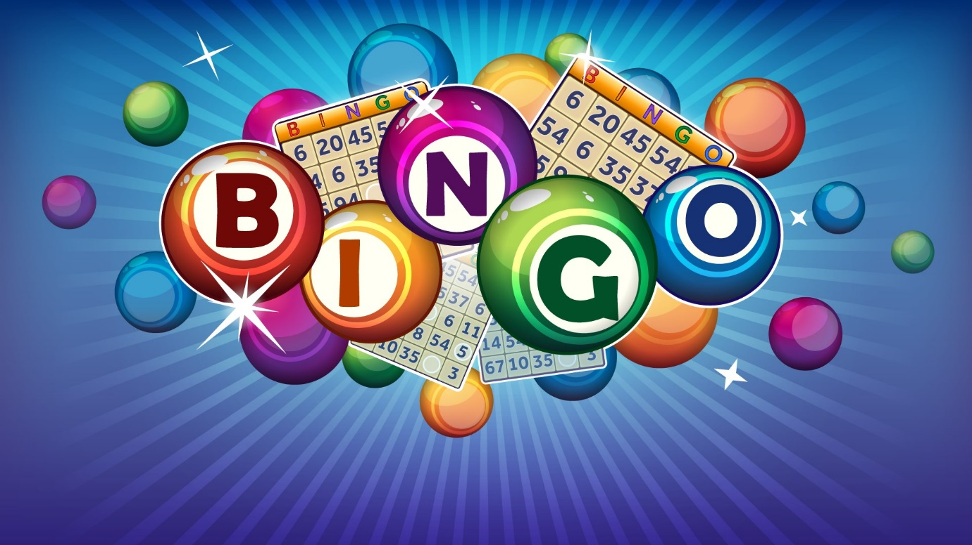

**FRIDAY 1st NOVEMBER**

**@ BIBC FROM 7PM**

 **EYES DOWN AT**

**7.30**